Implement Monitoring (Azure Monitor)

Lab Purpose
This lab teaches how to monitor Azure resources, detect important changes, and notify administrators automatically using Azure Monitor.
You will:
- Deploy a VM
- Enable monitoring
- Create alerts
- Send email notifications
- Suppress alerts during maintenance
- Query logs using KQL

Architecture diagram
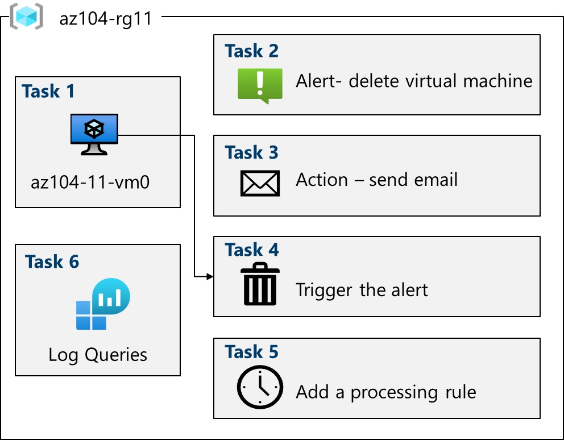

Core Concepts – Definitions (Very Important)

1. Azure Monitor
Azure Monitor is a centralized service that collects, analyzes, and acts on telemetry (metrics, logs, events) from Azure resources.
👉 Think of Azure Monitor as:
“The CCTV + alarm system for your Azure environment.”

2. Metrics
- Numeric values
- Collected automatically
- Near real-time
- Examples:
  - CPU usage
  - Memory usage
  - Disk IOPS
Used for performance monitoring.

3. Logs
- Detailed records of events
- Stored in Log Analytics Workspace
- Queried using KQL (Kusto Query Language)
Used for deep troubleshooting and auditing.

4. Azure Monitor Alerts
An alert automatically notifies you when something important happens.
Examples:
- VM deleted
- CPU > 80%
- VM stopped
- Disk full

5. Alert Rule
An alert rule defines:
- WHAT to monitor
- WHEN to trigger
- WHAT action to take
Structure:
Scope → Condition → Action

6. Action Group
An action group defines who gets notified and how.
Supported actions:
- Email
- SMS
- Push notification
- Voice call
- Webhook
- Logic App
👉 One action group can be reused across multiple alerts.

7. Activity Log
The Activity Log records subscription-level events such as:
- VM deletion
- Resource creation
- Configuration changes
Used for security and auditing.

8. VM Insights
VM Insights provides:
- Performance data
- Dependency mapping
- Guest OS metrics
Requires:
- Log Analytics Workspace
- VM agent

9. Alert Processing Rule
An alert processing rule controls alerts after they are triggered.
Common use:
- Suppress alerts during maintenance windows
- Avoid alert noise

10. KQL (Kusto Query Language)
KQL is used to query logs stored in Azure Monitor.
Example:
Heartbeat
| summarize count() by Computer
Used for:
- Analysis
- Dashboards
- Alert creation

Task 1 – Deploy Infrastructure (Why This Is Done)

What You Do
- Deploy a VM using an ARM template

Why
- You need a real resource to generate logs and alerts

Key Outcome
- VM + VNet created
- Monitoring target ready

Task 2 – Enable Azure Monitor (VM Insights)

What You Do
- Enable VM Insights from Azure Monitor

What Happens Internally
- VM agent is installed
- Logs and metrics start flowing to Log Analytics

Why It Matters
- Without this, log queries will not work

Task 3 – Create an Alert Rule (VM Deleted)

Alert Scenario
Notify admins if a VM is deleted.

Key Components Used
- Signal: Delete Virtual Machine (Activity Log)
- Scope: Subscription
- Condition: VM delete event
- Action: Send email

Why Subscription Scope?
- Any VM deletion in the subscription is detected

Task 4 – Configure Action Group

What Happens
- Email notification is configured
- You receive a confirmation email

Why Action Groups Are Important
- Centralized notification management
- Reusable
- Supports multiple channels

Task 5 – Trigger and Verify Alert

Action Taken
- VM is deleted manually

Result
- Alert is triggered
- Email notification received
- Alert visible in Azure Monitor → Alerts

Exam Tip
Deleting a VM generates multiple activity log alerts.

Task 6 – Alert Processing Rule (Maintenance Window)

Problem
Maintenance activities can cause unwanted alerts.

Solution
Alert processing rule to:
- Suppress notifications
- During specific time period

Key Benefit
- Reduces alert fatigue
- Keeps alerts meaningful

Task 7 – Azure Monitor Log Queries

What You Do
- Run built-in queries
- Run custom KQL queries

Sample Query Explained
InsightsMetrics
| where TimeGenerated > ago(1h)
| where Name == "UtilizationPercentage"
| summarize avg(Val) by bin(TimeGenerated, 5m), Computer
| render timechart

Meaning
- Get CPU usage
- Last 1 hour
- Average every 5 minutes
- Display as chart

